Modern Foreign Languages Department – St. Joseph’s College
Vision Statement:
The Modern Foreign Languages department at St. Joseph’s College aims to develop independent learning skills in all of our students, nurturing within them a lifelong love of languages. We aim to instil our students with skills and confidence, so that they begin to consider themselves as global citizens. We wish to explore new and exciting cultures alongside our students and to share with them the value and joy of communication.
Teaching groups:
- In both year 7 and year 8, students are taught languages within their form groups
- In year 7, all students are taught French
- In year 8, all students are taught both French and Spanish
- At the end of year 8, students opt to continue with either French or Spanish in year 9 and beyond. The most able and enthusiastic linguists are encouraged to study two languages in year 9 and through to GCSE level
How can I help my child with French / Spanish?
In terms of helping your child to progress in their work, the library has access to the internet and also stocks a number of French and Spanish magazines aimed at students. Students are encouraged to make use of the facilities on offer and there are several excellent internet resources that prove to be very useful. There are a selection of the best ones below:
USEFUL WEBSITES AND RADIO STATIONS FOR MFL STUDENTS
FRENCH & SPANISH: Word Reference – Online Dictionary http://www.wordreference.com – A fantastic online dictionary with a ‘verb conjugation’ tool that is very useful

FRENCH & SPANISH: BBC Bitesize - http://www.bbc.co.uk/schools/gcsebitesize/ - GCSE-style Listening and Reading questions that you can mark online. Stick to the ‘foundation’ activities. The grammar section is useful for those annoying little words (try Pronouns and When, where and how much)

FRENCH & SPANISH: Languages online http://www.languagesonline.org.uk - A variety of exercises in both languages.

FRENCH & SPANISH: Ashcombe - www.ashcombe.surrey.sch.uk A great website with loads of focussed exercises in both languages.
FRENCH & SPANISH: www.studystack.com Good for vocab revision
FRENCH: Zut! http://www.zut.org.uk/beginner/year9.html - This site is available for free apart from weekdays from 10am – 4pm. Listening and Reading exercises divided into topic areas.
FRENCH: French revision http://www.frenchrevision.co.uk/ - The Intermediate section contains core GCSE vocabulary and some sample exercises.
SPANISH: Spanish revision http://www.spanishrevision.co.uk/ - The Intermediate section contains core GCSE vocabulary and some sample exercises.
SPANISH: Spanish revision and games www.espanolextra.com Username: jpotts1 / Password: jpspanish - Revision and games.
SPANISH: ¡Oye! http://oye.languageskills.co.uk/index.html - This site is available for free apart from weekdays from 10am – 4pm. Listening and Reading exercises divided into topic areas.
FRENCH AND SPANISH RADIO:
It would also be great if students took the opportunity to listen to some French / Spanish radio. Here’s a brief list of a few radio stations / websites by way of an introduction:
French Radio:
- NRJ www.nrj.fr – Pop and chart music with some talking – possibly best to have on in the background
- Le Mouv http://www.lemouv.fr/ - French equivalent of Radio 1. Podcasts also available at http://www.lemouv.fr/podcasts
- Radio France http://www.radiofrance.fr/ - a variety of stations a bit like the BBC. Try France Info for news (don’t expect to understand everything though!)
- http://www.listenlive.eu/france.html - a list of all French radio stations streaming online.
Spanish Radio:
- Activa FM http://www.activafm.es/ – Pop and chart music with some talking – possibly best to have on in the background
- Rac105 http://www.rac105.cat/radio - Spanish rock and pop station.
- RTVE http://www.rtve.es/radio/ - Spanish news / info / features
- www.listenlive.eu/spain.html - a list of all Spanish radio stations streaming online.
Learning vocabulary as it is covered in class is an essential ingredient in language learning and parents are encouraged to practise and “test” vocabulary with pupils whenever possible rather than just for a formal assessment.
For students in year 8 there is a French trip to Paris which we recommend to all students of French to improve both listening and speaking skills.
For students in year 9 there is a French exchange which is also highly recommended.
We are hoping to expand on our extra-curricular opportunities and provide students with the possibility of visiting Spain in the near future.
Course outline:
Year 7 and 8:
The course in both French and Spanish aims to provide pupils with the skills required to learn independently and enables them to be well prepared for the continued and successful study of a language at Key Stage 4. We aim to equip our pupils with an understanding of grammar, as well as providing them with the confidence to speak in the target language; being able to express and justify their opinions and communicate on a range of topics.
The curriculum we follow includes units of work based on the following topics:
- Greetings
- Family and friends
- Daily routine
- School life
- Free time and hobbies
- Town and the world around us
- Food
- Life in France / Life in Spain
We also aim to build in units of work which include cross-curricular themes.
Students in KS3 are assessed across the four skill areas of listening, speaking, reading and writing.
What are we learning in year 7 French and year 8 French?
 | Year 7 French | Year 8 French
Autumn 1 | - (Baseline test)  - Greetings  - Objects in school bag (indefinite article)  - Alphabet  - Phonics  - Numbers 1-31  - Objects in a classroom (definite article) | - Routines  - What you do in the morning  - What you do after school  - What you do in the evening  - Review of time and time phrases  - Reflexive verbs  - Use of nous / on
Autumn 2 | - School subjects  - Opinions (positive and negative adjectives)  - Verb conjugation in the present tense (regular –er verbs)  - Extended opinions  - Days of the week  - Telling the time  - School day | - Musical instruments  - jouer de  - Sport  - Games  - jouer à vs. faire de  - Giving opinions and reasons for likes and dislikes  - aimer + infinitive  - At the leisure centre  - on peut + infinitive
Spring 1 | - Where you live  - Countries (au, en, aux)  - Types of property  - Adjectives and adjectival agreement  - Rooms in a house  - Objects in a bedroom  - Prepositions | - Future tense  - aller + infinitive  - Going on holiday  - Exploring the French speaking world  - Transport  - Completing extended piece of writing incorporating 2 tenses  - Opinions in the future tense  - Memory techniques
Spring 2 | - Brothers and sisters  - Family members  - Conjugating avoir  - Possessive adjectives  - Pets  - Describing yourself and others  - Hair and eyes  - Plural adjectival agreement | - Consolidation of the present tense and the future tense  - Exam preparation  - Exam technique  - Revision of daily routine  - Revision of free time activities  - Revision of holidays
Summer 1 | - Places in a town  - Directions  - Use of the preposition à  - Revision of numbers  - Revision of telling the time  - Days of the week  - Months of the year  - ‘Ultimate revision guide’ | - Preparation for a trip to France  - How to book tickets and accommodation  - Asking for directions  - Asking for help  - Asking for food in a café / restaurant  - Useful travel phrases  - Going to tourist information

What are we learning in year 8 Spanish?
 | Year 8 Spanish
Autumn 1 | - (Baseline test)  - Greetings  - Exchanging personal information  - Objects in school bag (indefinite article)  - Alphabet  - Phonics  - Numbers 1-31  - Birthdays  - Months of the year  - Objects in a classroom (definite article)  - Learning about Spanish speaking countries  - Learning the Spanish alphabet
Autumn 2 | - School subjects  - Using –ar verbs  - Talking about what you do in class  - Using –er and –ir verbs  - Talking about your teachers  - Making adjectival agreements  - Giving opinions and reasons  - Talking about snacks
Spring 1 | - Talking about family  - Using tener  - Pets  - Making colours agree with nouns  - Personal physical descriptions – eyes and hair  - Using tener and ser in the he/she form  - Basic descriptions of personality traits
Spring 2 | - Describing where you live  - Talking about your home  - Beginning to write longer passages  - Activities you do in your house  - Description of bedroom
Summer 1 | - Daily routine  - Using reflexive verbs  - Revision and consolidation of all topics studied in preparation for the exam

Due to the demanding nature of the new GCSE course, the MFL department has decided to designate year 9 as a ‘bridging year’.

Current year 9 French content (2016-2017)
Current students of year 9 French are following a three year mapping grid to prepare them for the demands of the new GCSE. Our current year 9 students will sit their MFL GCSE in summer 2019.
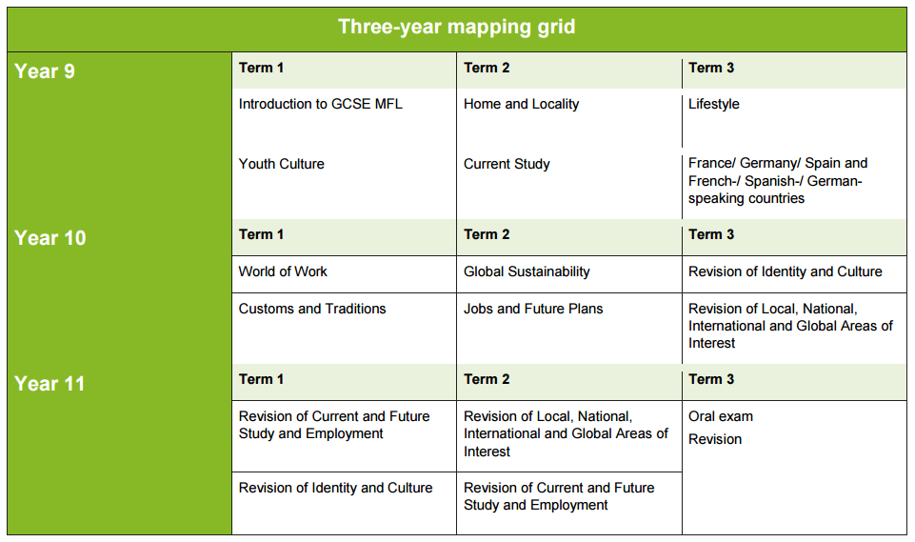
Current year 9 Spanish content (2016-2017)
Current students of year 9 Spanish follow a slightly different path to their French counterparts to account for the fact that they have studied the language for a year less. Therefore, in order to ensure that the curriculum is covered as thoroughly as possible, we adopt a different approach. The content is listed below:

- Town and local area describing facilities for young people, considering Spanish speaking cities. (Grammar: tenses as stated above / comparisons)
- Free time activities sports, film genre / TV shows / likes and dislikes
- Spanish customs and traditions food and drink / shopping at the market and quantities / ordering food (Grammar: the past tense)
- A day out transport / shopping for clothes / problems with clothes / using adjectives to describe (Grammar: consolidation of the past tense / adjectival agreement and position)

Current year 10 MFL students
We follow the Eduqas Specification for both French and Spanish at GCSE for current year 10.
Modern Foreign Languages GCSE Assessment (Eduqas)
25% - Listening examination - end of year 11
25% - Speaking examination (NEA) - end of year 11
25% - Reading examination - end of year 11
25% - Writing examination - end of year 11
All four components of the GCSE examination will be examined either at higher level or at foundation level. NB No mixing of tiers is permitted.
Current year 10 French content (2016-2017)
Current students of year 10 French are following the two year scheme of work detailed below. Our current year 10 students will sit their MFL GCSE in summer 2018.
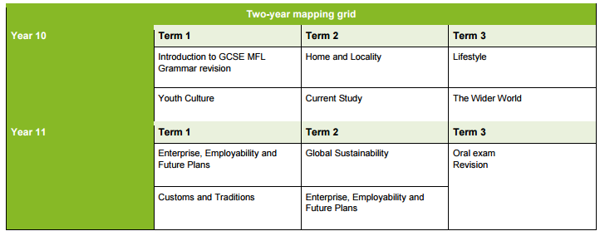

Current year 10 Spanish content (2016-2017)
Current students of year 10 Spanish are following the two year scheme of work detailed below. Our current year 10 students will sit their MFL GCSE in summer 2018.

Year 10 | Year 11
YOUTH CULTURE:  Self and relationships | ENGLAND AND THE WORLD – AREAS OF INTEREST  The wider world – Countries and holidays
CURRENT STUDY AND FUTURE EMPLOYMENT  Current study | ENGLAND AND THE WORLD – AREAS OF INTEREST  The wider world – Festivals and customs
ENGLAND AND THE WORLD – AREAS OF INTEREST  Home and locality/Global sustainability | IDENTITY AND CULTURE: Lifestyle
IDENTITY AND CULTURE –  Youth Culture | ENGLAND AND THE WORLD – AREAS OF INTEREST  Global sustainability
ENTERPRISE, EMPLOYABILITY AND FUTURE PLANS  Career plans and employment | Exam practice and final revision / consolidation

Current year 11 MFL students (examined in 2017)
We follow the WJEC Specification for both French and Spanish at GCSE for current year 11.
WJEC GCSE French: http://www.wjec.co.uk/qualifications/french/french-gcse/
WJEC GCSE Spanish: http://www.wjec.co.uk/qualifications/spanish/spanish-gcse/
The content that we study covers the following broad contexts:
- Personal and Social Life
- The Local Community
- The World of Work
- The Wider World

Modern Foreign Languages GCSE Controlled Assessment Policy (WJEC)
Controlled assessments count for 60% of the final GCSE grade. Controlled assessment tasks take place over the course of year 10 and year 11. The two units assessed by controlled assessment tasks are:
Speaking (Unit 2) (30%) - which consists of two tasks: a presentation and follow-up discussion, and a structured conversation.
Writing (Unit 4) (30%) which consists of two tasks: these are both written tasks of approximately 300 words, chosen from a central task bank provided by the WJEC.
The remaining 40% of the final grade is comprised of a Listening Examination (Unit 1) worth 20% of the final grade and a Reading Examination (Unit 3) worth 20% of the final grade. Both of these examinations take place at the end of year 11 and can be taken at either foundation or higher tier.
Current year 11 French content (2016-2017)
 | Year 11 French
Autumn 1 | - Holidays  - Transport and travel  - Holiday activities  - Lost property  - Services  - Weather  - Booking accommodation  - Problems in a hotel  - Making a complaint  - Using the past, present and future tenses  - Giving opinions  - Preparing for written controlled assessment (2)
Autumn 2 | - Intensive past paper practice ready for mock exam  - Social issues  - Greatest concerns of young people  - Drugs, alcohol, smoking  - Crime, violence  - Unemployment  - Homelessness  - Religion, politics  - Recycling  - Mock exam – analysis and consolidation exercises
Spring 1 | - Parts of the body  - Illnesses; visits to the doctor’s/dentist  - Healthy / unhealthy lifestyle  - Talking about mealtimes  - Describing your daily routine and that of others  - Saying what one should/shouldn’t do re: food, smoking and alcohol  - Finding out about different people’s lifestyles  - Vocabulary consolidation
Spring 2 | - Free time  - Reference to personal free time activities and those common amongst European youngsters  - Cinema – asking about opening/closing times  - Buying tickets  - Invitations  - Making arrangements to meet and accepting invitations  - Television  - Vocabulary consolidation
Summer 1 | - Focus on consolidation and extension of vocab and exam technique  - REVISION

Current year 11 Spanish content (2016-2017)
 | Year 11 Spanish
Autumn 1 | - Lost property  - Services  - Illnesses  - Controlled assessment piece preparation (topic and title varies from year to year)  - Introduction to past papers
Autumn 2 | - Preparation for mock exam in form of reading and listening comprehensions – past and practice with a wide variety of accompanying vocab and grammar exercises  - Mock exam – analysis and consolidation exercises (topic and title varies from year to year)
Spring 1 | - Preparation for speaking exam i) Presentation  - Any additional pieces of controlled assessment to be done by end of April  - Vocabulary consolidation
Spring 2 | - Final focus on consolidation and extension of vocab and exam technique
Summer 1 | - REVISION

KS5 – Year 12 (Linear A-level MFL examined in summer 2018)
Assessment in MFL (French and Spanish)
2 exams and 1 ‘non-exam assessment’
- Component 1 – Speaking, ‘non-exam assessment’ (worth 30%)
- Component 2 – Listening, Reading and Translation (worth 50%)
- Component 3 – Critical and analytical response in writing (closed-book) (worth 20%)
Component 1 30% of A level – 21-23 minutes (including 5 minutes preparation) which is an Oral ‘non-exam assessment’
- Task 1 - (a) Presentation of independent research project (2 mins)
(b) Discussion on the content of the research project (9-10 mins)
- Task 2 – Discussion based on a stimulus card relating to one of the themes studied (5 mins prep. time followed by 5-6 mins discussion) No dictionaries permitted
Component 2 50% of A level - 2½ hours formal examination
Listening, Reading and Translation
- Listening exercises
- Reading exercises
- Translation from Target Language to English and from English to Target Language
No dictionaries permitted
Component 3 20% of A level – 2 hours formal examination
2 essays
- One based on a literary work and the second on an additional literary work or film from the prescribed list
No dictionaries OR texts permitted

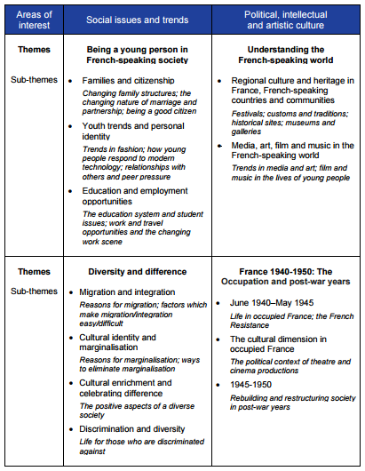
Current year 12 French content (2016-2017)

Current year 12 Spanish content (2016-2017)
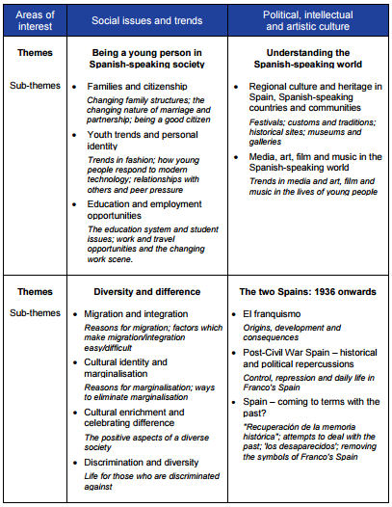

KS5 – A2 (Current year 13, examined in summer 2017)
The WJEC specification for A2 is designed to encourage students to develop their understanding of the language in a variety of contexts and genres, to communicate confidently and effectively in the language and to develop an awareness and understanding of the contemporary society, cultural background and heritage of the countries in which French and Spanish is spoken.

WJEC A2 French: http://www.wjec.co.uk/qualifications/french/french-gce-a-as/

WJEC A2 Spanish: http://www.wjec.co.uk/qualifications/spanish/spanish-gce-a-as/

A2
- Environmental Issues, including: technology, pollution, global warming, transport, energy, nuclear energy, renewable energies, conservation, recycling and sustainability

- Social and Political Issues, including: the role of the media, racism, immigration social exclusion and integration, terrorism, world of work (employment, commerce, globalisation, etc.)

In addition, at A2 French, students study a French film of their choice for their speaking examination.
At A2 Spanish, students study a region of Spain or South America for their speaking examination.

In both A2 French and A2 Spanish a film is studied for the essay section within the written component of the examination.

Current year 13 French and Spanish content (2016-2017)

FN3 / SN3 (Oral) |  | FN4 / SN4 (Listening, Reading, Writing)
The speaking topics correspond directly with the topics studied for the larger FN4 / SN4 module. We will undertake speaking tasks throughout the course. An exposé on a specific topic (chosen by student and teacher) must be given and follow up questions will also be asked. | Autumn 1 | Pollution / Global warming / Conservation / Recycling and Sustainability Role of the media / Preparation for oral exposé
 | Autumn 2 | Transport / Energy / Nuclear Energy / Renewable Energies
 | Spring 1 | Social Exclusion and Integration / Terrorism / World of work (employment, commerce, globalisation, etc.)
 | Spring 2 | Racism / Immigration / Technology
 | Summer 1 | Preparation for FN3 / SN3 Oral  Revision of all topics covered*

*Occasionally, the order of topics may differ according to staffing / current affairs

The examinations at the end of Year 13 are as follows:

- FN3 or SN3 – SPEAKING EXAMINATION (15 minutes and is worth 40%)
- FN4 or SN4 – LISTENING, READING and WRITING (3 hours and is worth 60%)

The speaking examination will be based on (1) a structured discussion on a short written stimulus and linked to one of the topics and (2) a presentation on a French film of their choice or a Spanish speaking region.

The FN4 or SN4 examination mirrors the tasks at AS with the essay (of 400 words) based on the film.

